DCC-GARCH correlation: EURUSD and USDJPY
Method 09 / GARCH(1,1) + Engle DCC / Alpari D1 full available history

Study setup
Logical pair: EURUSD , USDJPY
Broker symbols: EURUSD_i , USDJPY_i
Snapshot: 2026-11-03_majors_alpari_D1
Timeframe: D1
Matched return window: 1999-01-05 to 2026-11-02 (UTC bar dates)
Matched return count n: 7200
Dropped unfinished last bar dated 2026-11-03 UTC after a tick-volume check against the prior complete day.
EURUSD GARCH(1,1): mu=0.000006, omega=0.001153, alpha=0.036771, beta=0.959944
USDJPY GARCH(1,1): mu=0.000113, omega=0.005008, alpha=0.052022, beta=0.935301
DCC: a=0.048271, b=0.930831, a+b=0.979102
Burn-in ignored in path summaries and chart: first 60 updates
Complete matched rows (Excel): EURUSD-USDJPY_DCC_D1.xlsx
Complete matched rows (HTML table): EURUSD-USDJPY_DCC_D1_data.html

Method carried forward
DCC-GARCH first fits a constant-mean GARCH(1,1) on each matched daily log return of close, ln(close_t / close_t-1), then updates Engle (2002) dynamic conditional correlation on the standardised shocks z = residual / conditional sigma. Quotes are not inverted. Correlation targeting sets Q_bar to the sample correlation of z; a and b are estimated by maximising the bivariate Gaussian DCC likelihood with a >= 0, b >= 0, and a + b < 1. Path summaries ignore the first 60 updates. The headline is rho on the last day. Same-sample Pearson r on log returns is a side check only. A high |rho| does not prove cause, lead-lag, or a trading signal.

Results
Latest DCC rho: -0.373270
Post-burn-in path (n=7140): mean=-0.366010, median=-0.403552, min=-0.743699, max=0.483334, std=0.200330
Share of post-burn-in days with |rho| >= 0.4: 50.84%; |rho| >= 0.7: 0.73%
Same-sample Pearson r: -0.300952
Latest rho minus r: -0.072318

Conclusion
Over 7200 matched daily log-return rows for EURUSD and USDJPY (broker quote directions unchanged), latest DCC rho is -0.3733 (negative, weak conditional linear link in this sample) with fitted a=0.0483, b=0.9308 (a+b=0.9791). After a 60-day burn-in, path mean is -0.3660 and std is 0.2003. Same-sample Pearson r is -0.3010 (latest rho minus r = -0.0723). This does not establish cause, lead-lag, or a lasting trading rule.

Charts
Daily closes

Daily log returns
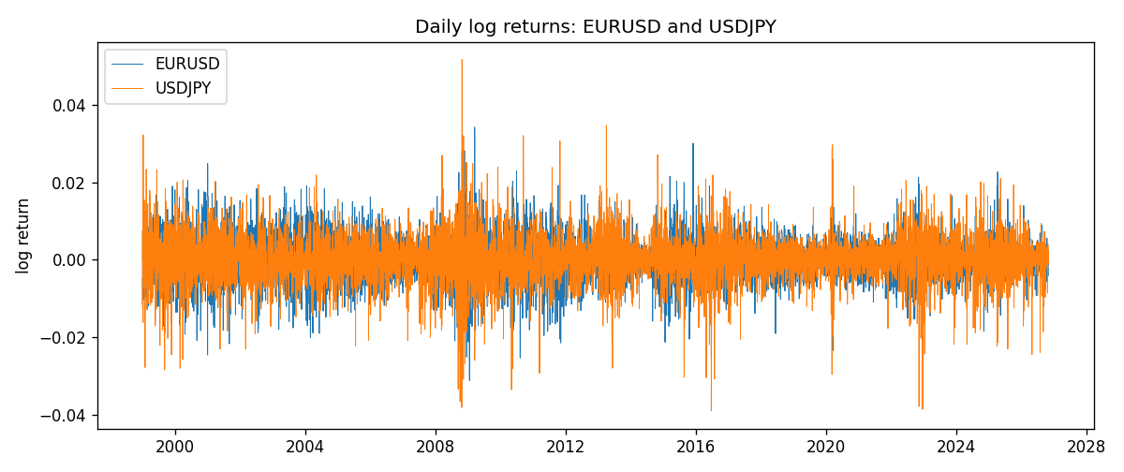
DCC rho path with Pearson r reference
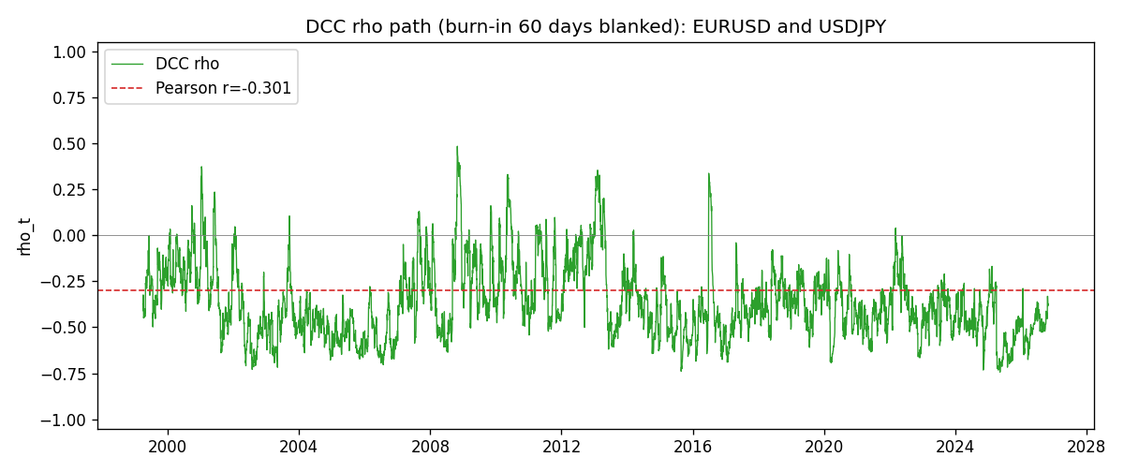

Data report
Every matched row that entered the DCC recursion is stored in the sibling Excel workbook named EURUSD-USDJPY_DCC_D1.xlsx. Embedding all rows as a Word table is impractical at this length; the Word file holds the column list, column summaries, and the first and last 15 matched rows.
Columns: time, EURUSD_open, USDJPY_open, EURUSD_high, USDJPY_high, EURUSD_low, USDJPY_low, EURUSD_close, USDJPY_close, EURUSD_tick_volume, USDJPY_tick_volume, EURUSD_spread, USDJPY_spread, EURUSD_real_volume, USDJPY_real_volume, EURUSD_log_return, USDJPY_log_return, EURUSD_sigma, USDJPY_sigma, EURUSD_z, USDJPY_z, q11, q22, q12, rho_t
Column summaries (matched calculation rows)
column | count | mean | std | min | 25% | 50% | 75% | max
EURUSD_open | 7200 | 1.1812699 | 0.15089907 | 0.8272 | 1.086045 | 1.16609 | 1.2939325 | 1.5995
USDJPY_open | 7200 | 113.80877 | 19.206548 | 75.693 | 104.4225 | 110.983 | 120.69125 | 163.824
EURUSD_high | 7200 | 1.1864006 | 0.15149686 | 0.8326 | 1.0901575 | 1.17121 | 1.2991625 | 1.6038
USDJPY_high | 7200 | 114.3063 | 19.268128 | 76.001 | 104.878 | 111.441 | 121.26 | 163.978
EURUSD_low | 7200 | 1.1762568 | 0.15022122 | 0.8227 | 1.0819775 | 1.162475 | 1.288265 | 1.5865
USDJPY_low | 7200 | 113.28572 | 19.134551 | 75.402 | 103.8875 | 110.53 | 120.17 | 163.628
EURUSD_close | 7200 | 1.1813075 | 0.15087411 | 0.8267 | 1.085995 | 1.16602 | 1.2939425 | 1.5997
USDJPY_close | 7200 | 113.82186 | 19.221964 | 75.811 | 104.4165 | 111.023 | 120.6855 | 163.851
EURUSD_tick_volume | 7200 | 103020.56 | 173417.03 | 218 | 9398.5 | 52714 | 99443.25 | 1471626
USDJPY_tick_volume | 7200 | 106139.77 | 179306.98 | 149 | 9927.5 | 53095 | 92761 | 1803508
EURUSD_spread | 7200 | 19.389444 | 16.57873 | 0 | 8 | 12 | 30 | 50
USDJPY_spread | 7200 | 20.3175 | 17.636173 | 0 | 6 | 11 | 30 | 50
EURUSD_real_volume | 7200 | 4.0252061e+10 | 1.6676396e+11 | 0 | 0 | 0 | 0 | 3.6149665e+12
USDJPY_real_volume | 7200 | 3.4708591e+10 | 1.6077621e+11 | 0 | 0 | 0 | 0 | 3.8834203e+12
EURUSD_log_return | 7200 | -1.012e-05 | 0.00580063 | -0.03123819 | -0.0032472 | 0 | 0.00325137 | 0.03433183
USDJPY_log_return | 7200 | 4.989e-05 | 0.00620383 | -0.03908203 | -0.00319719 | 0.00011638 | 0.00340925 | 0.05184024
EURUSD_sigma | 7200 | 0.00556697 | 0.00169853 | 0.00257921 | 0.00432257 | 0.00538963 | 0.00649694 | 0.01459445
USDJPY_sigma | 7200 | 0.00599078 | 0.00174037 | 0.00337195 | 0.00477706 | 0.00569213 | 0.00679079 | 0.0188299
EURUSD_z | 7200 | -0.00306844 | 1.0000302 | -5.7814238 | -0.61983469 | -0.00096284 | 0.60822171 | 5.207937
USDJPY_z | 7200 | -0.00915608 | 1.0002787 | -6.5322391 | -0.56387758 | 0.00045357 | 0.58084601 | 7.1025818
q11 | 7200 | 1.0003378 | 0.227987 | 0.56394054 | 0.84782723 | 0.96400818 | 1.1094291 | 2.708378
q22 | 7200 | 1.0010505 | 0.29184638 | 0.48712046 | 0.81058953 | 0.94113736 | 1.1184813 | 3.1356943
q12 | 7200 | -0.36019503 | 0.24347189 | -1.7918312 | -0.49532823 | -0.35856763 | -0.23023609 | 0.98112295
rho_t | 7200 | -0.36555628 | 0.19984513 | -0.74369858 | -0.50526546 | -0.40285862 | -0.25816589 | 0.48333395
First 15 matched rows (selected columns)
time | EURUSD_log_return | USDJPY_log_return | EURUSD_sigma | USDJPY_sigma | EURUSD_z | USDJPY_z | q11 | q22 | q12 | rho_t
1999-01-05 | -0.0048360507 | -0.00017868311 | 0.0065768869 | 0.011227428 | -0.73616708 | -0.026016173 | 1 | 1 | -0.35994213 | -0.35994213
1999-01-06 | -0.011547966 | 0.0075660159 | 0.0065192112 | 0.010881395 | -1.7722394 | 0.68489419 | 0.97788912 | 0.95176176 | -0.3416429 | -0.35413061
1999-01-07 | 0.0076280636 | -0.012851583 | 0.0067691588 | 0.010683364 | 1.1260523 | -1.2135685 | 1.0827585 | 0.92947034 | -0.38412496 | -0.38290318
1999-01-08 | -0.010902799 | -0.0047719894 | 0.0067998437 | 0.010770104 | -1.6042187 | -0.45360758 | 1.0899705 | 0.95716878 | -0.43104174 | -0.4220051
1999-01-11 | -0.007103287 | -0.016195423 | 0.0069911849 | 0.010499182 | -1.0168411 | -1.5533434 | 1.1597025 | 0.92179265 | -0.37362308 | -0.36136309
1999-01-12 | 0.0045103728 | 0.032310364 | 0.0069923165 | 0.010836899 | 0.64424084 | 2.9710485 | 1.1502956 | 0.99540296 | -0.27905798 | -0.26078959
1999-01-13 | 0.010845346 | 0.0081373171 | 0.0069134332 | 0.012816758 | 1.5679199 | 0.62604799 | 1.1116636 | 1.3735436 | -0.17488394 | -0.14152788
1999-01-14 | 0 | 0 | 0.0070934473 | 0.012549557 | -0.00079467369 | -0.0090371004 | 1.174337 | 1.3183543 | -0.12292703 | -0.098794996
1999-01-15 | -0.010153245 | 0.0055343401 | 0.0069582192 | 0.012157439 | -1.459983 | 0.44589395 | 1.1140074 | 1.2480672 | -0.12194596 | -0.10341997
1999-01-18 | 0.0036256946 | 8.7600193e-05 | 0.007098427 | 0.01184357 | 0.50998026 | -0.0021793607 | 1.1607427 | 1.1922351 | -0.15245735 | -0.12959834
1999-01-19 | -0.00017235436 | -0.0056219403 | 0.0069976093 | 0.011475873 | -0.025436021 | -0.49977476 | 1.1139077 | 1.1306678 | -0.14948771 | -0.1332028
1999-01-20 | -0.0031939256 | -0.0053879917 | 0.0068645186 | 0.01119764 | -0.46610153 | -0.49130026 | 1.0577892 | 1.0854156 | -0.14605618 | -0.13630832
1999-01-21 | 0.0030215416 | 0.0084664056 | 0.0067620904 | 0.010924742 | 0.44600181 | 0.76459414 | 1.0160079 | 1.042888 | -0.13242181 | -0.12864477
1999-01-22 | -0.0012075213 | 0.0060412564 | 0.0066591329 | 0.010759121 | -0.18217961 | 0.55095993 | 0.97623172 | 1.01987 | -0.11432347 | -0.11457412
1999-01-25 | -0.0030251979 | -0.0073594164 | 0.0065373729 | 0.010516561 | -0.46361664 | -0.71057715 | 0.93120691 | 0.98487767 | -0.11878297 | -0.12403377
Last 15 matched rows (selected columns)
time | EURUSD_log_return | USDJPY_log_return | EURUSD_sigma | USDJPY_sigma | EURUSD_z | USDJPY_z | q11 | q22 | q12 | rho_t
2026-10-13 | 0.0037402957 | -0.0018932826 | 0.0034532253 | 0.0048718549 | 1.0814987 | -0.41189531 | 1.0037994 | 0.72382418 | -0.36319825 | -0.42609235
2026-10-14 | -0.0037582255 | 7.5800166e-05 | 0.0034749557 | 0.0047864027 | -1.0831397 | -0.0078579763 | 1.0117253 | 0.70284551 | -0.36710126 | -0.43533605
2026-10-15 | 0.0056053107 | -0.0018524319 | 0.0034968401 | 0.0046827683 | 1.6013525 | -0.41980372 | 1.0192744 | 0.67513135 | -0.34882049 | -0.42049641
2026-10-16 | 0.0017724895 | -0.00037976126 | 0.0036064446 | 0.0046055885 | 0.48991533 | -0.1070814 | 1.0934528 | 0.65783819 | -0.36466532 | -0.42996678
2026-10-19 | -0.0025394633 | 0.0034946841 | 0.0035658915 | 0.0045113818 | -0.71373462 | 0.7494982 | 1.0503037 | 0.63378764 | -0.34949622 | -0.42836418
2026-10-20 | 0.0023881672 | -0.0022546642 | 0.0035439765 | 0.0044867994 | 0.67227597 | -0.52778732 | 1.0231434 | 0.63796321 | -0.35866619 | -0.4439401
2026-10-21 | -0.00032046717 | -0.00032883504 | 0.0035186277 | 0.0044296099 | -0.092679355 | -0.099838735 | 0.99508798 | 0.62818021 | -0.35850714 | -0.45344534
2026-10-22 | -0.0015949606 | -0.0085942669 | 0.003464688 | 0.0043431506 | -0.46197452 | -2.0049221 | 0.94757144 | 0.60610872 | -0.34078501 | -0.44967551
2026-10-23 | -0.001338521 | 0.00035080446 | 0.0034253129 | 0.0046997728 | -0.39241905 | 0.050511561 | 0.91322894 | 0.77911794 | -0.28002571 | -0.33197584
2026-10-26 | -0.0022706559 | 0.0041238746 | 0.0033829828 | 0.0046002782 | -0.67286564 | 0.87178707 | 0.87839323 | 0.7462483 | -0.2691355 | -0.33241822
2026-10-27 | -0.004152342 | 0.0027651658 | 0.0033603594 | 0.0045968359 | -1.2373614 | 0.57686509 | 0.86038826 | 0.75221555 | -0.28635724 | -0.35595064
2026-10-28 | 0.0022262927 | -0.00095679538 | 0.0034045221 | 0.0045420686 | 0.65226651 | -0.23562105 | 0.89567992 | 0.73714683 | -0.3085276 | -0.3797
2026-10-29 | 0.0022571351 | -0.00038043789 | 0.0033798161 | 0.0044560107 | 0.66615996 | -0.11082772 | 0.87516163 | 0.70973698 | -0.30212778 | -0.38335207
2026-10-30 | -0.0011458446 | -0.0010596481 | 0.0033566842 | 0.0043686245 | -0.34304139 | -0.26851924 | 0.85694675 | 0.68213607 | -0.29231578 | -0.38233128
2026-11-02 | 0.002120569 | 0.0026438521 | 0.0033136227 | 0.0042921462 | 0.63825371 | 0.58955131 | 0.82425103 | 0.65933183 | -0.27517228 | -0.37326985

